**Web Application:** this application usage Microsoft Cognitive Services Face API to Identify and Recognize human faces from live WebCam.

**Scenario 1:** 1st time user, hence system didn’t identified her.

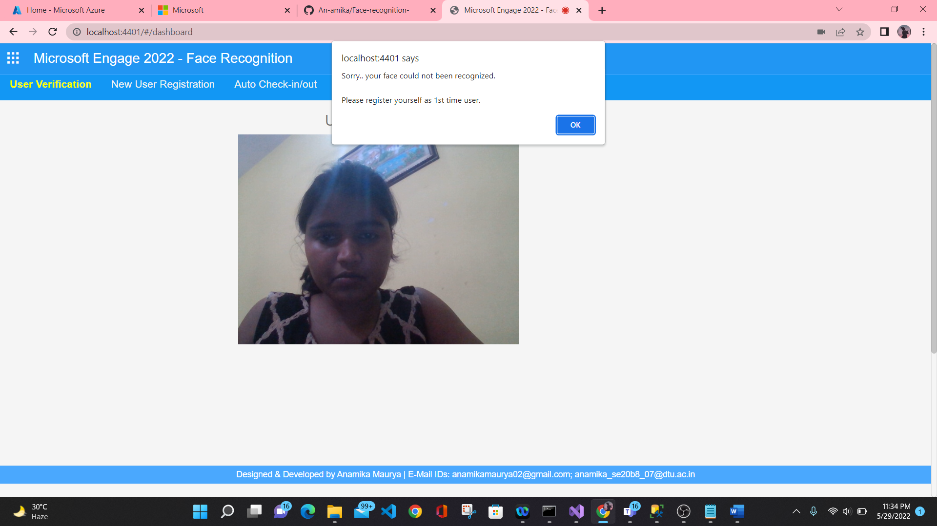

**Scenario 2:** 1st time user, since system didn’t identified her. She is getting registered for 1st time.

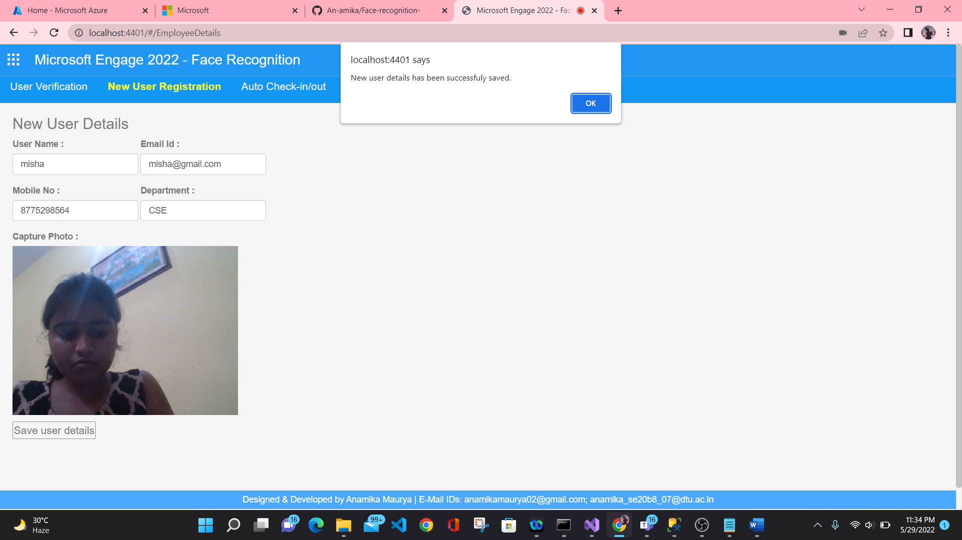

**Scenario 3:** user check in with her face details

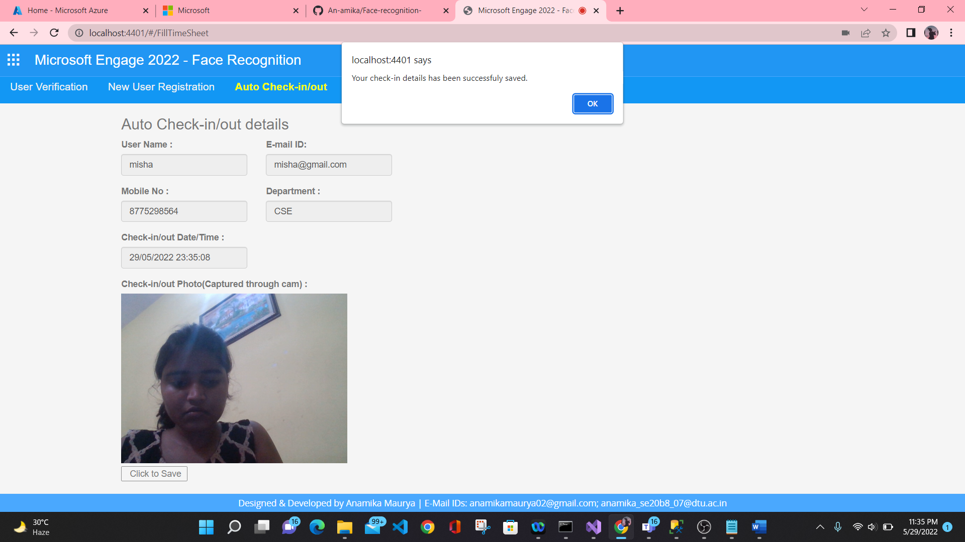

**Scenario 4:** system Recognized in her next visit. 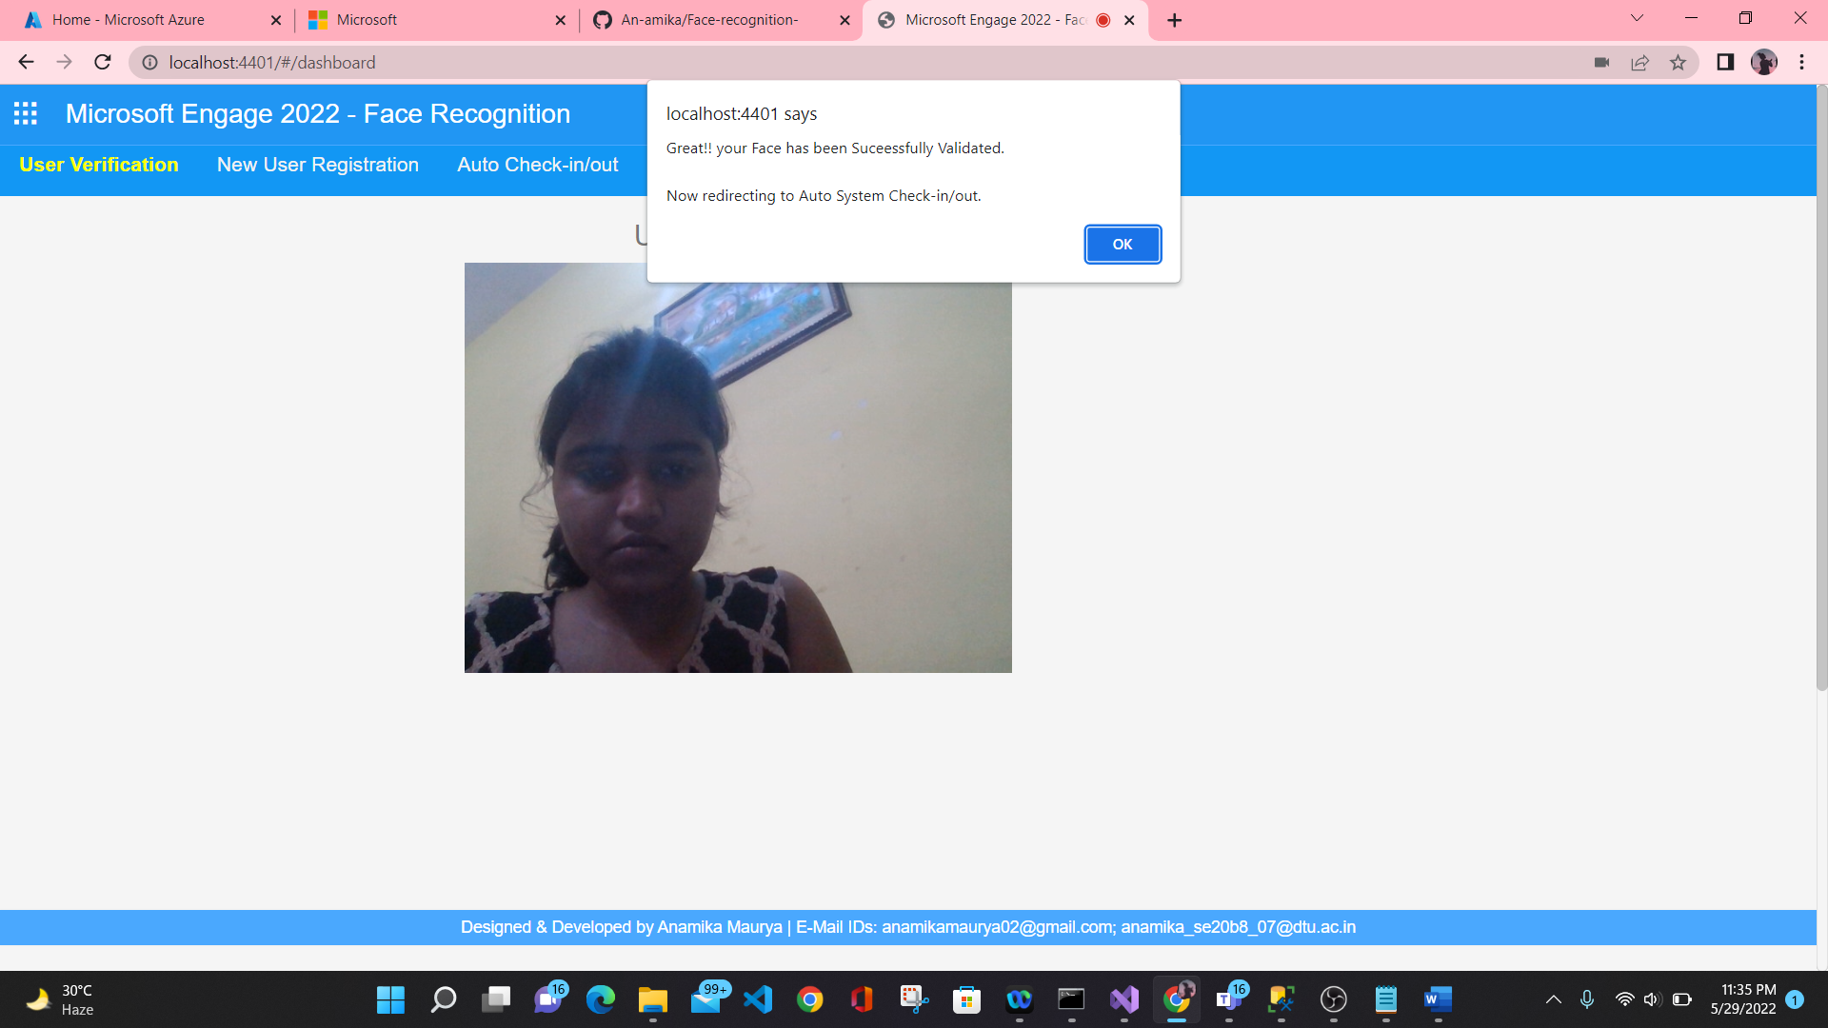

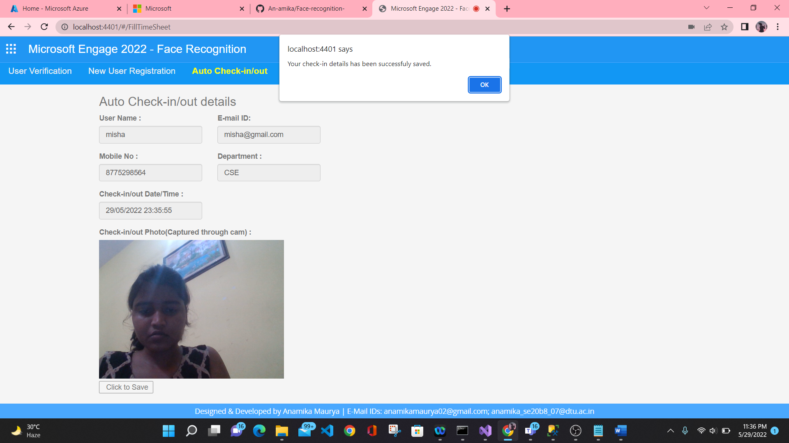

**Scenario 5:** Face Recognition based check-in/out details.

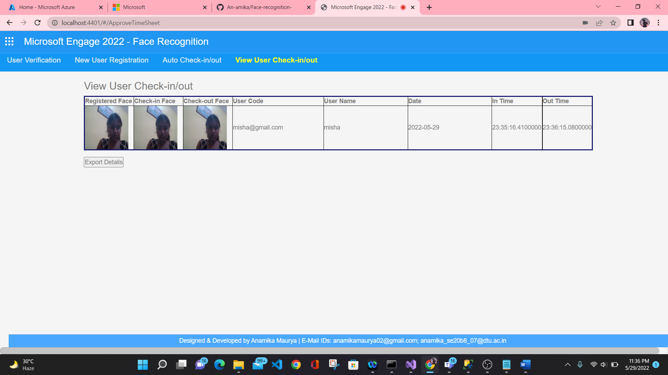

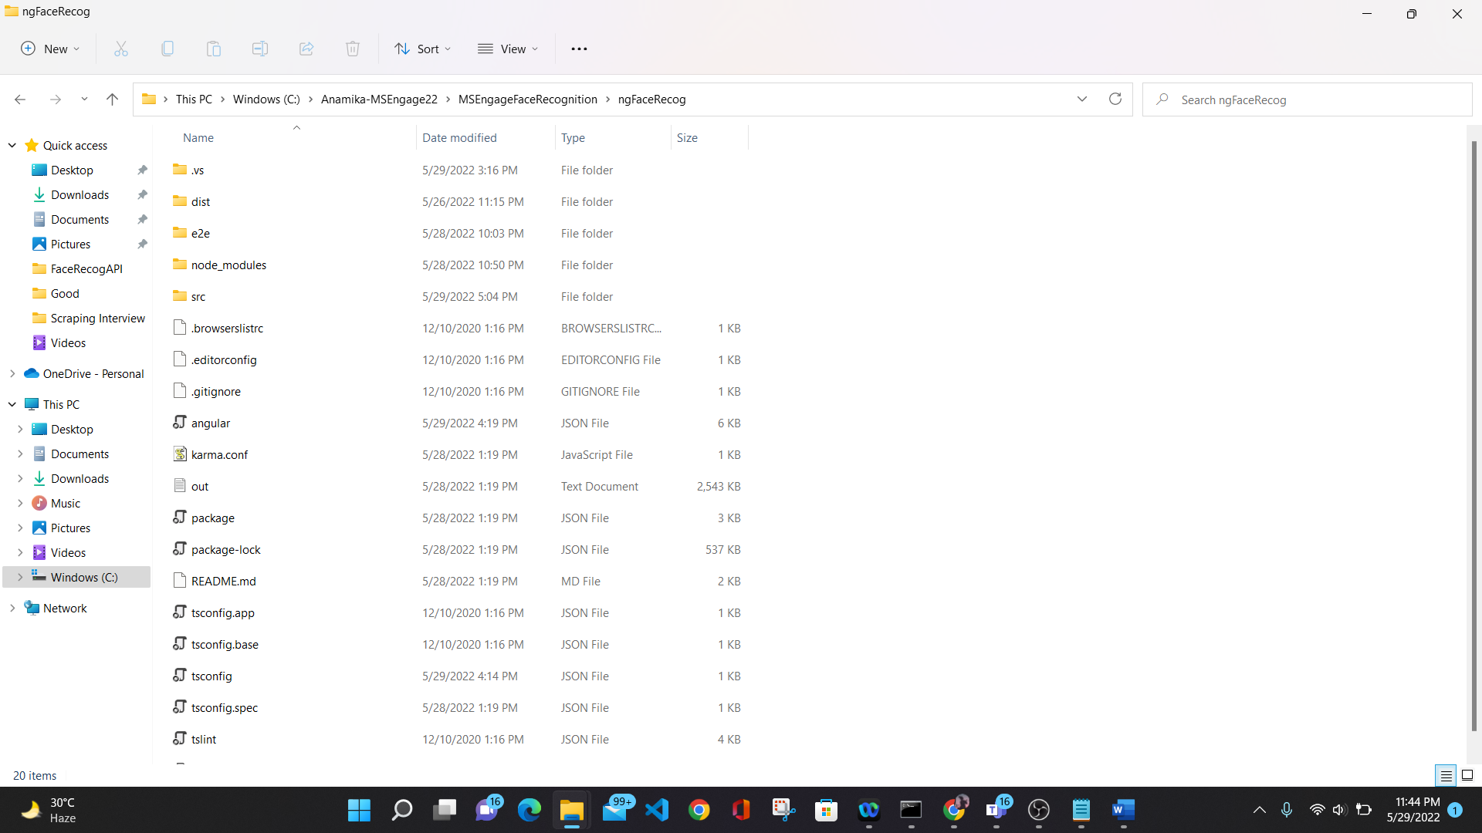

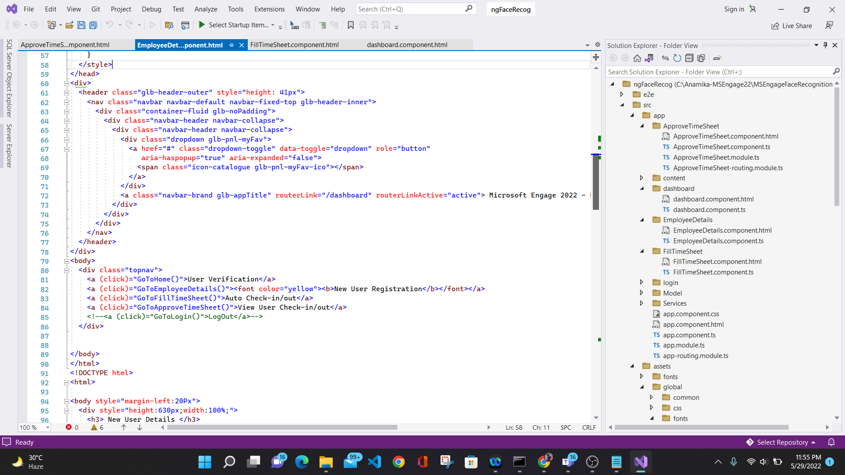

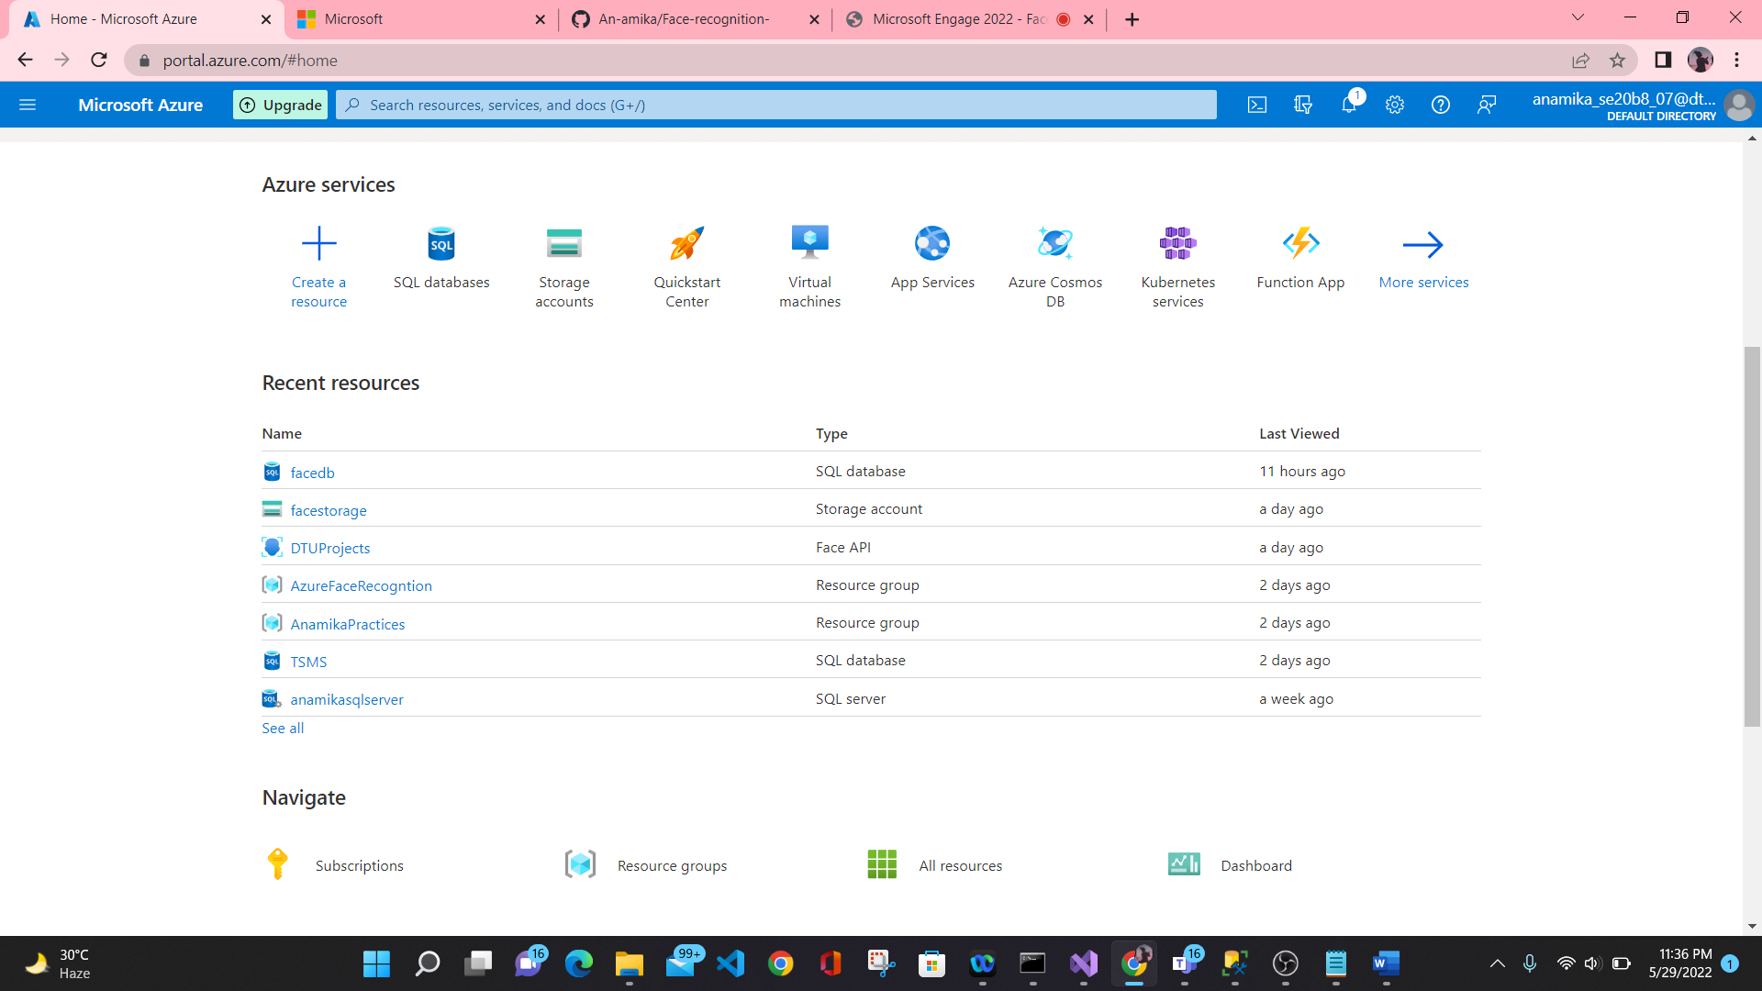

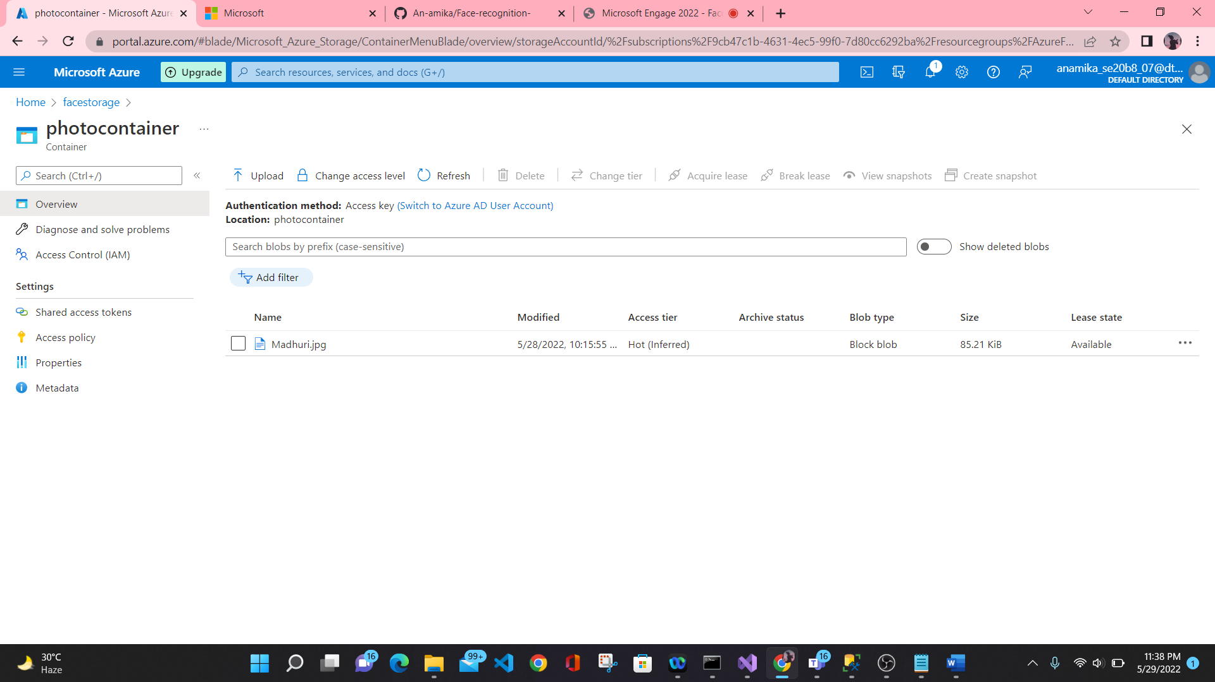

**APIs:** various APIs are developed and used as below to communicate through SQL Server DB, Azure Face API to Identify and Recognize the Faces & saving an retrieving photos in Blob container.



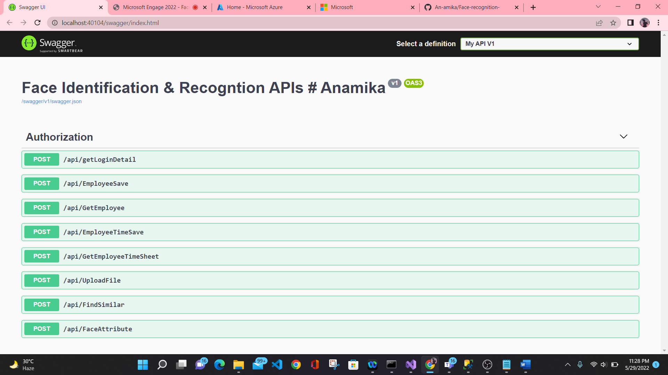

**SQL Server Database**

